**Intro to Deep Learning**

The term, Deep Learning, refers to training Neural Networks, sometimes very large Neural Networks.

ReLU Function -

Rectified

Linear

Unit

You see this ReLU function often.

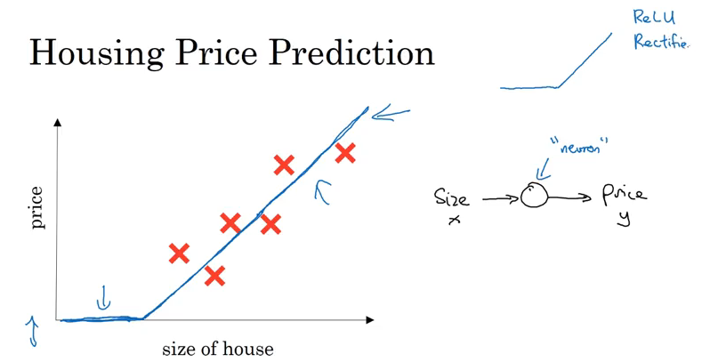

**Supervised Learning with Neural Networks**

Almost all the economic value created by neural networks has been through one type of machine learning, called supervised.

Possibly the single most lucrative application of deep learning today is online advertising.

Computer vision has also made huge strides in the last several years, mostly due to deep learning.

Speech recognition has also been very exciting, where you can now input an audio clip to a neural network, and have it output a text transcript.

Machine translation has also made huge strides thanks to deep learning where now you can have a neural network input an English sentence and directly output say, a Chinese sentence.

Autonomous driving

**Neural Networks and Their Applications**

Standard Neural Network

Real Estate

Online Advertising

Convolution Neural Network

Image - Photo Tagging

Recurrent Neural Network

Audio - Speech Recognition

English - Machine Translation

Custom Neural Network

Autonomous Driving

**Why is Deep Learning taking off?**

We went from having a small amount of data to having a lot of data because of the “Internet of Things”. Most traditional learning algorithms, were successful with a small amount of data. As the amount of data gets larger and larger, the amount of data that is required to produce better results is larger and larger. You want to train a larger neural network or throw more data at it in most cases.

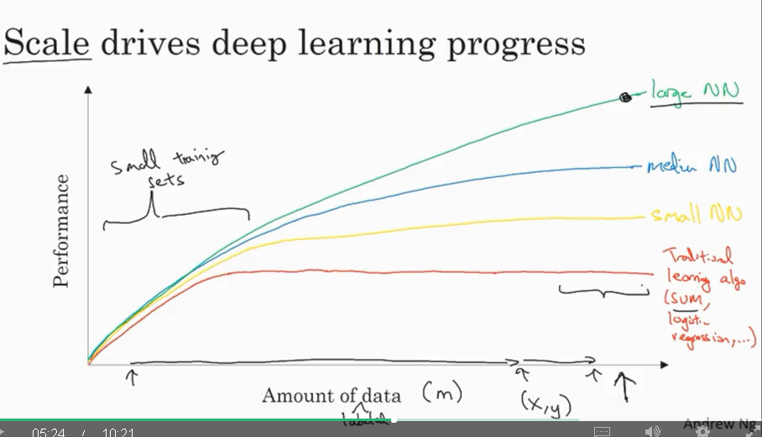

Here is a graphical view of how neural networks outperform traditional algorithms.

Lower Case (m): Number of training examples

Scale Drives deep learning progress

* Data
* Computation
* Algorithms

Most advances have been from switching from a **sigmoid** function to a **ReLU** function.

Faster computation has helped with testing new ideas and experimenting each of those ideas more often.

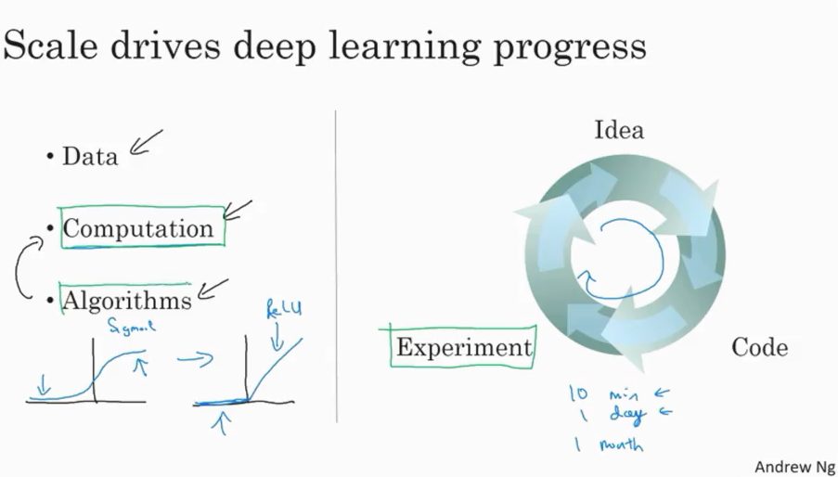

**About this Course**

What is expected:

Course 1 teaches the most fundamental basics of deep learning.

Outline of This Course

Week 1: Introduction

Week 2: Basics of Neural Network Programming.

Week 3: One Hidden Layer Neural Network

Week 4: Deep Neural Networks